1.19 For Each Controller with Xpath Extractor



This section will guide you to understand:

* How to add For Each controller with Xpath Extractor in JMeter

**Development Environment:**

* Apache Jmeter 5.1.1 Version
* JDK Runtime Environment 8.1

This guide has four subsections, namely:

1.19.1 Adding thread group

1.19.2 Adding For Each controller

1.19.3 Adding Xpath extractor and debugging sampler

1.19.4 Pushing the code to GitHub repositories

**Step 1.19.1:**  Adding thread group

* Open JMeter.
* Right click on Test Plan-->Add-->Threads-->Thread Group.

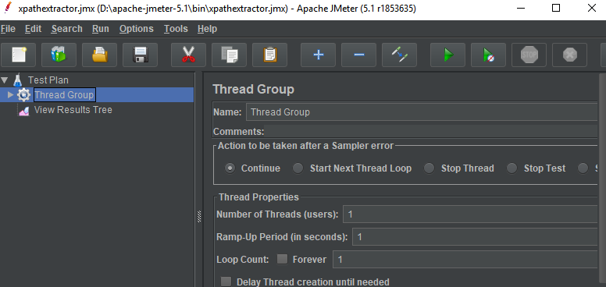

* Right click on Thread-->Add-->Sampler -->Xpath Extractor--> HTTP Request.

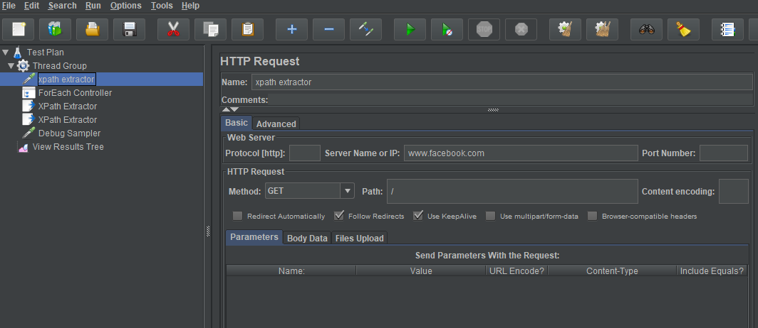

**Step 1.19.2:**  Adding For Each controller

* Right click on Thread Group-->Add -->Logic Controllers-->For Each Controller.

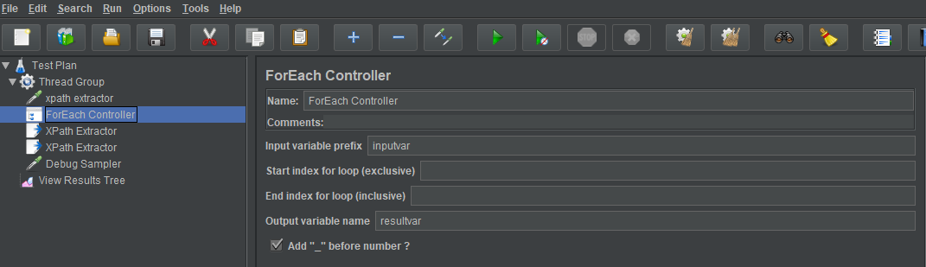

**Step 1.19.3:**  Adding Xpath extractor and debug sampler.

* Right click on Thread Group-->Add -->PostProcessor-->Add two Xpath Extractor with different values as shown in below:

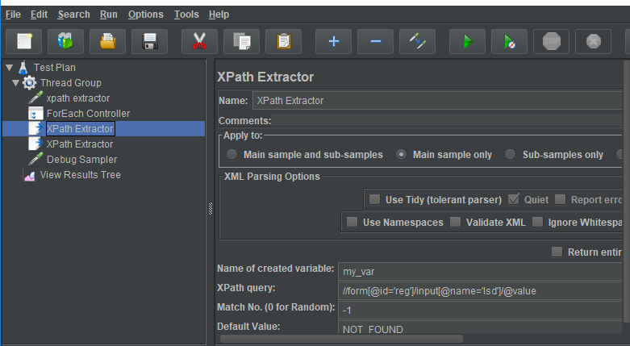

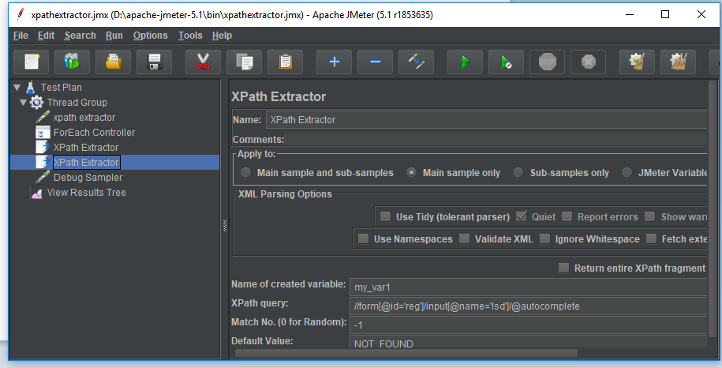

* Right click on Thread Group-->Add -->Sampler-->Debug Sampler.

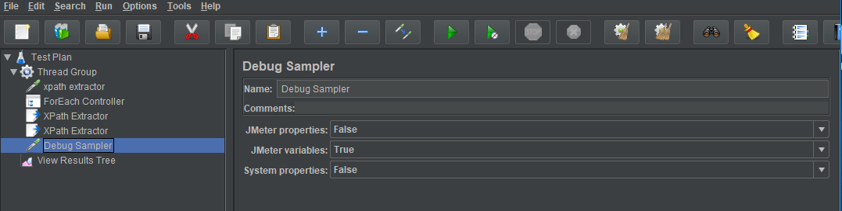

* Right click on Test Plan--> Add-->Listener-->View Result Tree.

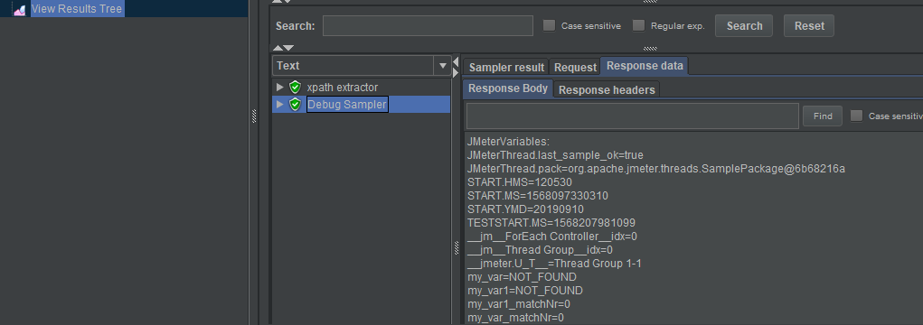

**Step 1.19.4:** Pushing the code to GitHub repositories

Open your command prompt and navigate to the folder where you have created your files.

cd <folder path>

Initialize your repository using the following command:

git init

Add all the files to your git repository using the following command:

git add . 

Commit the changes using the following command:

git commit . -m “Changes have been committed.”

Push the files to the folder you initially created using the following command:

git push -u origin master